What is Django?
Django is a Python framework that makes it easier to create web sites using Python.
Django takes care of the difficult stuff so that you can concentrate on building your web applications.
Django emphasizes reusability of components, also referred to as DRY (Don't Repeat Yourself), and comes with ready-to-use features like login system, database connection and CRUD operations (Create Read Update Delete).
Django History
Django was invented by Lawrence Journal-World in 2003, to meet the short deadlines in the newspaper and at the same time meeting the demands of experienced web developers.
Initial release to the public was in July 2005.
Latest version of Django is 4.0.3 (March 2022).
How does Django Work?
Django follows the MVT design pattern (Model View Template).
- Model - The data you want to present, usually data from a database.
- View - A request handler that returns the relevant template and content - based on the request from the user.
- Template - A text file (like an HTML file) containing the layout of the web page, with logic on how to display the data.

Model
- The model provides data from the database.
- In Django, the data is delivered as an Object Relational Mapping (ORM), which is a technique designed to make it easier to work with databases.
- The most common way to extract data from a database is SQL. One problem with SQL is that you have to have a pretty good understanding of the database structure to be able to work with it.
- Django, with ORM, makes it easier to communicate with the database, without having to write complex SQL statements.
- The models are usually located in a file called models.py.

View
- A view is a function or method that takes http requests as arguments, imports the relevant model(s), and finds out what data to send to the template, and returns the final result.
- The views are usually located in a file called views.py.

Template
- A template is a file where you describe how the result should be represented.
- Templates are often .html files, with HTML code describing the layout of a web page, but it can also be in other file formats to present other results, but we will concentrate on .html files.
- Django uses standard HTML to describe the layout, but uses Django tags to add logic:
<h1>My Homepage</h1>

<p>My name is {{ firstname }}.</p>
The templates of an application is located in a folder named templates
URLs
Django also provides a way to navigate around the different pages in a website.
When a user requests a URL, Django decides which view it will send it to.
This is done in a file called urls.py.
Django Requires Python
Step 1
Download Python from https://www.python.org/
Download Visual Studio Code from https://code.visualstudio.com/download
Download DB Browser from from https://sqlitebrowser.org/dl/
To check if your system has Python installed, run this command in the command prompt: win+R -> cmd-> enter
>>python --version
If Python is installed, you will get a result with the version number, like this
Python 3.13.2
Step 2
Install Django in cmd
>>pip install Django
Check Django Version
You can check if Django is installed by asking for its version number like this:
C:\Users\Your Name>django-admin –version
Step 3
Create a folder on desktop named projects
Go to cmd
>cd location/foldername
C:/Desktop/foldername>
Step 4
Create Project in folder name
C:/Desktop/foldername>django-admin startproject demo
C:/Desktop/foldername>
Means Project has been created.
Step 5
Open folder in VS Code
File -> open folder -> foldername -> projectname->click
Now here we get

ProjectName
manage.py
ProjectName/
__init__.py
asgi.py
settings.py
urls.py
wsgi.py
Make migrations
In terminal
>>python manage.py makemigrations
After this sqllite3 file will be created with no data in it .
>>python manage.py migrate
After this SqlLite3 file reflects data in it.
Run the Django Project
Now that you have a Django project, you can run it, and see what it looks like in a browser.
Navigate to the / folder and execute this command in the command prompt:
python manage.py runserver
Which will produce this result:
Watching for file changes with StatReloader
Performing system checks...
System check identified no issues (0 silenced).
You have 18 unapplied migration(s). Your project may not work properly until you apply the migrations for app(s): admin, auth, contenttypes, sessions.
Run 'python manage.py migrate' to apply them.
March 19, 2025 - 14:19:38
Django version 5.1.7, using settings 'projectname.settings'
Starting development server at http://127.0.0.1:8000/
Quit the server with CTRL-BREAK.
Open a new browser window and type 127.0.0.1:8000 in the address bar.
The result:
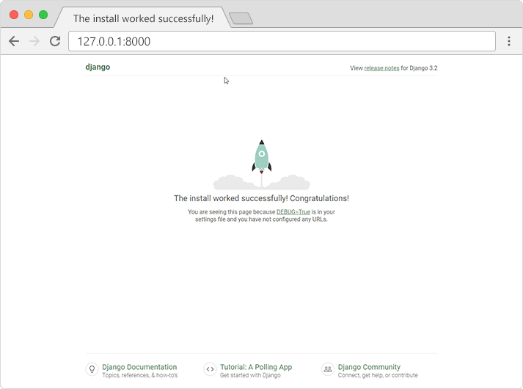
Creating Super User for admin Panel
>>python manage.py createsuperuser
>>Username (leave blank to use 'victus'): nisha
>>Email address: nisha@gmail.com
>>Password:
>>Password (again):
This password is too common.
This password is entirely numeric.
>>Bypass password validation and create user anyway? [y/N]: y
Superuser created successfully.
Run Server Again
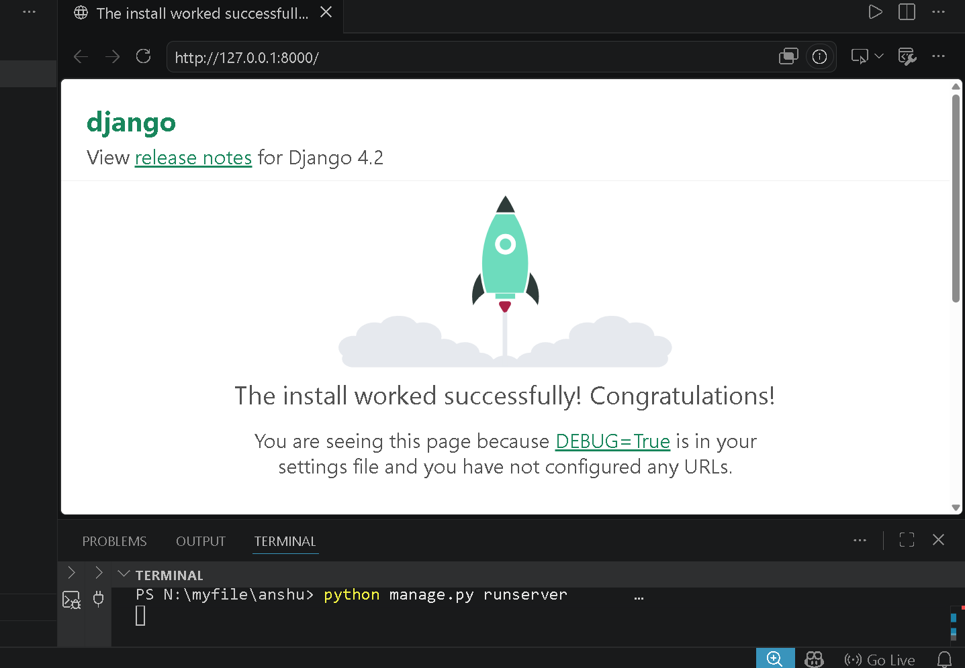

In link http://127.0.0.1:8000/admin
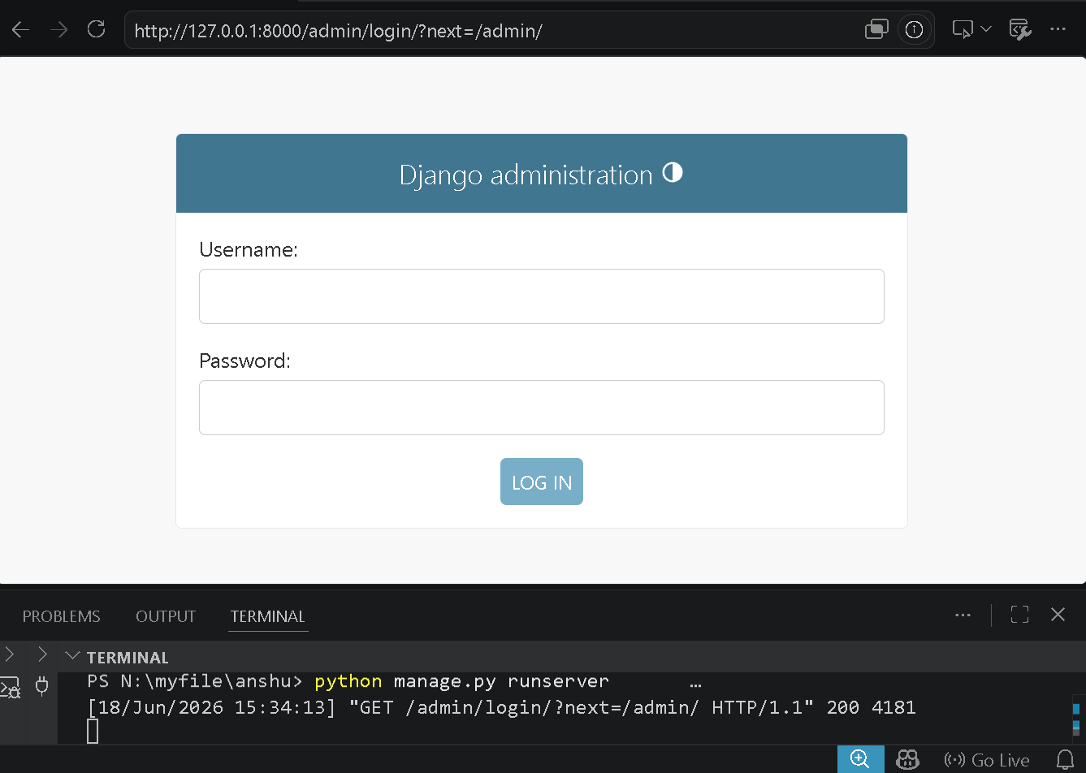
Enter the username & password given during the super user creation
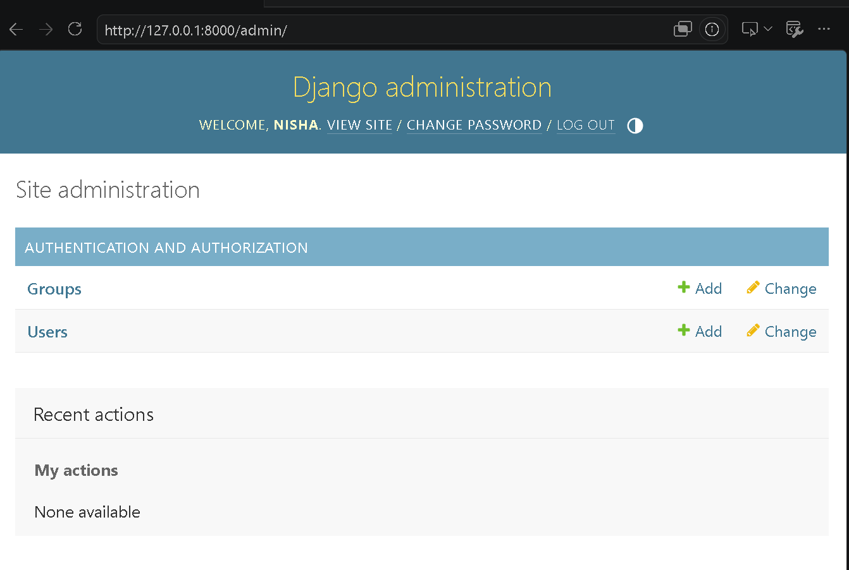
Now logout from Admin Panel
What is an App?
An app is a web application that has a specific meaning in your project, like a home page, a contact form, or a members database.
In this tutorial we will create an app that allows us to list and register members in a database.
Create App
Go to terminal
>>python manage.py startapp home
Go to main app settings.py add created in INSTALLED_APPS
INSTALLED_APPS = [
'django.contrib.admin',
'django.contrib.auth',
'django.contrib.contenttypes',
'django.contrib.sessions',
'django.contrib.messages',
'django.contrib.staticfiles',
'home',
]
Go to home app -> views.py
from django.shortcuts import render
from django.http import HttpResponse
# Create your views here.
def myhome(request):
return HttpResponse("Hello, World! This is my home page.")
Go to main App -> urls.py to create url for the function created in home app views.py
from django.contrib import admin
from django.urls import path
from home import views
urlpatterns = [
path('admin/', admin.site.urls),
path('', views.myhome, name='myhome'),
]
OR
from django.contrib import admin
from django.urls import path
from home.views import *
urlpatterns = [
path('admin/', admin.site.urls),
path('', myhome, name='myhome'),
]

Now Runserver


